

FEP-0800

8 FE PoE Switch
User Manual

Ver 1.0

Introductions
Thank you for purchasing the PoE Switch.
The PoE Switch, is a 8-port 10/100Mbps PoE Switch with PoE On/Off control capability. With 8 dip switches, each PoE port can be manually set for On-Off control. 8-Port PoE Switch supports up to 15.4W/30W on each LAN port when the corresponding port DIP switch is set ON.

The PoE Switch supports power protections as OVP (Over Voltage Protection), OCP (Over Current Protection), OTP (Over Temperature Protection), robust short-circuit protection and surge protection. You may also make use of PoE repeater to extend another 100 meters or serveral 100 meters distance if multiple PoE repeaters are cascaded.

Application
PoE Switch Connects with PoE PD Devices
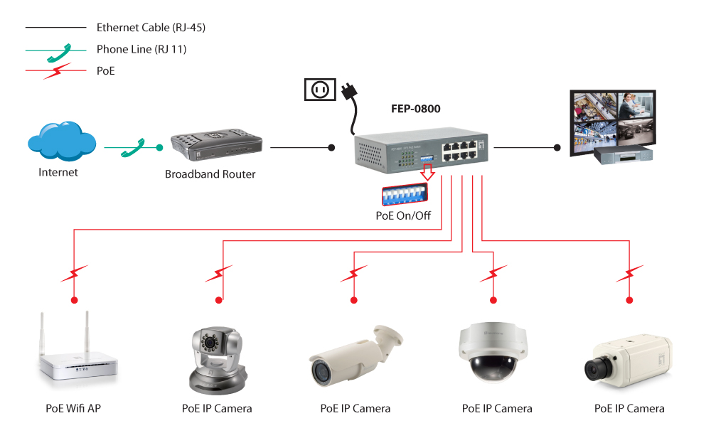

Packing Contents
Inside the package you shall find:
    - 8-Port PoE Switch
    - Power Adapter
    - User Manual
Please check if the packing is damaged or any component is missing. If so, please contact your distributor.

Technical Specifications
Standards | IEEE 802.3/u 10/100BaseT/TX
Standards | IEEE 802.3x Flow Control
Standards | Midspan PoE compliant
Features | MAC Address: 4K
Features | Buffer Memory: 512KB
Features | Transmission Method: Store and Forward
Filtering/Forwarding Rates | 100Mbps port - 148,800pps
Filtering/Forwarding Rates | 10Mbps port - 14,880pps
Transmission Media | 10BaseT Cat. 3, 4, 5 UTP
Transmission Media | 100BaseTX Cat. 5 UTP
PoE on each Port | 30W
Output PoE Pin | 4, 5, 7, 8
LED Indicators | Port 1~8: 10/100M, PoE ON/OFF, Power
Power Adaptor | Input: 100-240VAC, 50~60Hz  Output: 56VDC 1.6A (90W)
Dimensions | 165 × 100 × 40 mm (L x W x H)
Weight | 0.6 kg
Operating Temperature | 0 to 50℃
Humidity | 10 to 90% RH (non-condensing)
Certifications | FCC Class A, CE

LED Indicators
On the front panel of 8-Port FE PoE Switch, there are 17 LED indicators as the following;

POWER: “Green On” indicates power is on and normal.

Port 1~8 LAN: “Green On” indicates each Ethernet LAN port is in connection.
PoE: “Green On” indicates Power over Ethernet function is enabled for each port.
“OFF” indicates the PoE is disabled, and it becomes a regular LAN port.

Dip Switch Settings vs Power over Ethernet
 | 1 ~ 8 ports DIP ON
Per PoE Port | 15.4/30 Watts Injected
Maximum PoE Power | 85 Watts

Note that the dip switches can be switched ON and OFF anytime. However, it is suggested that the dip switches be set ready before the PoE port is connected for power management.

The device will be re-started if the overall PoE power consumption is over the power budget. Please make less PoE ports enabled when over the power budget.

